**SNSOP Tool (Uploader)**

1. First user needs to login and import database if needed.
2. User can see the imported DB’s beneficiary stats in the bottom taskbar of the app like following: -



1. Clicking ‘Pending’ or ‘Failed’ label will show a list of not uploaded beneficiary records. Here user can select which beneficiary records to upload to AFIS server.

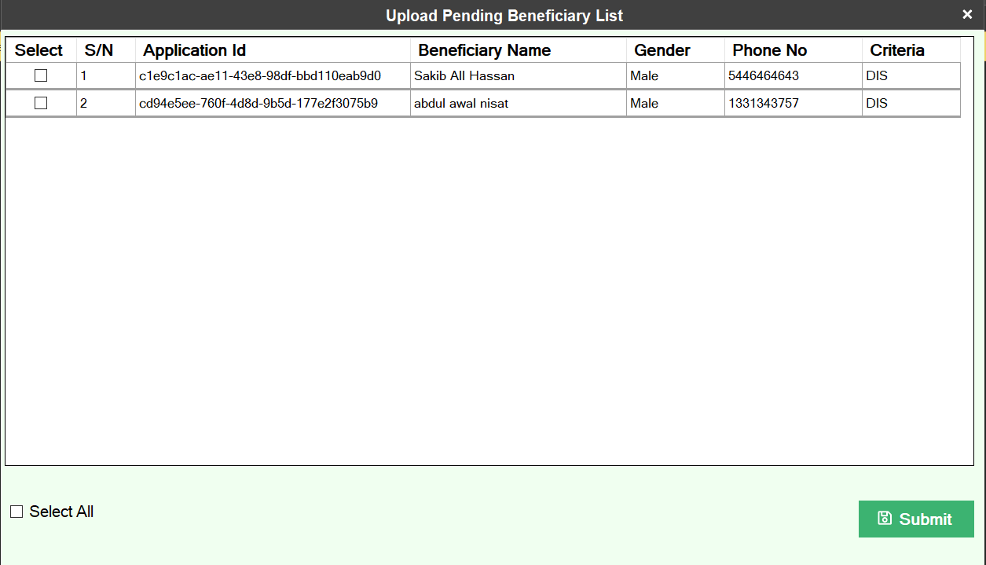

1. Clicking ‘Total’ or ‘Uploaded’ label will show list of appropriate beneficiaries like following: -

